**Sequence Diagram for Concentration game:** (PlantUML txt file attached) 

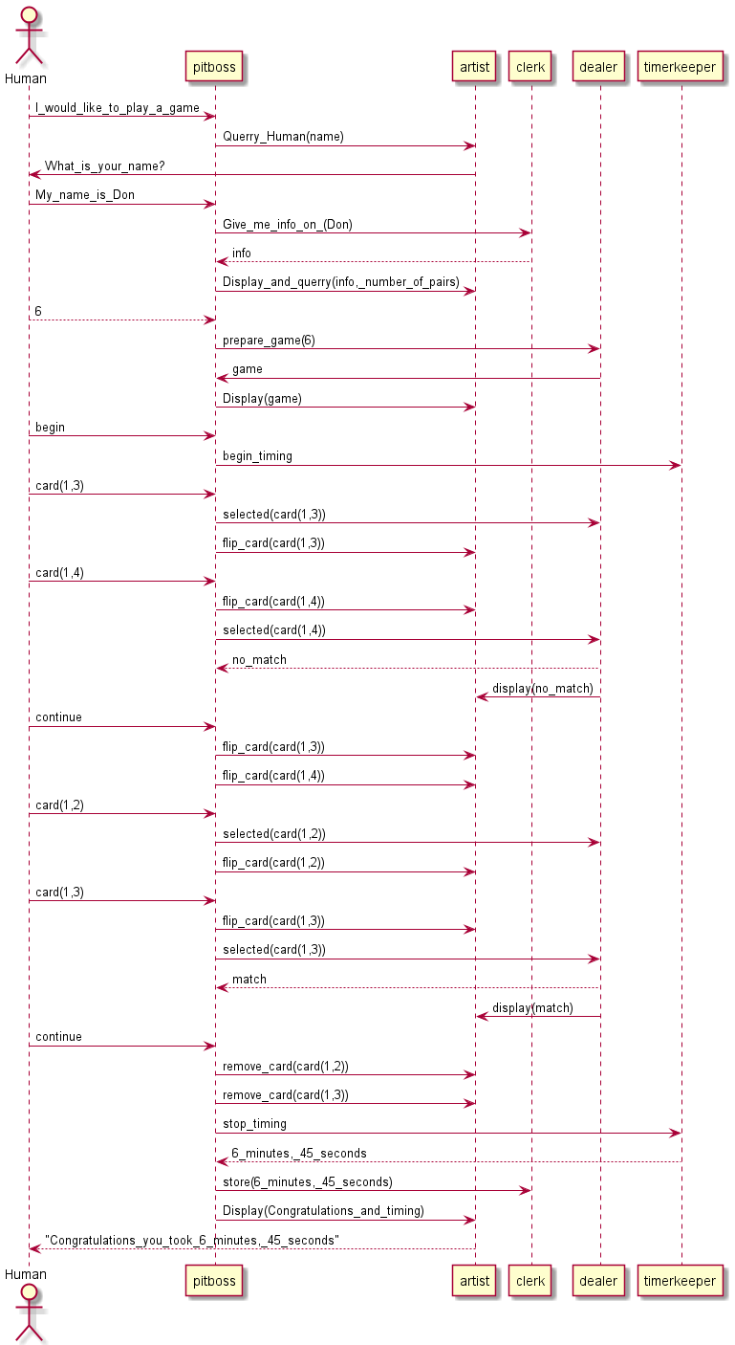

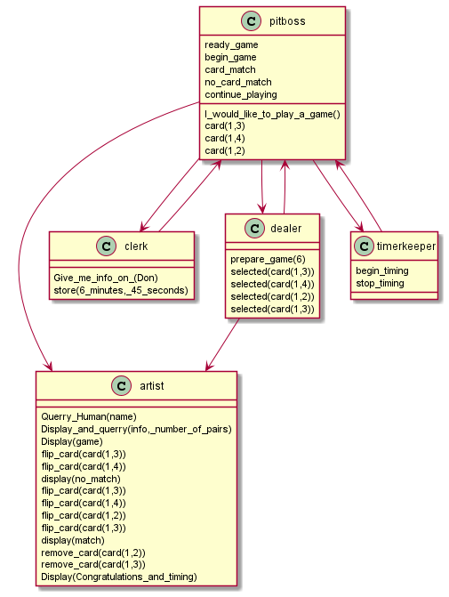**Class Diagram for Concentration Game:** (PlantXML txt file attached) 